**MEMORANDUM**

**6/10/2022**

| **TO:** | Charlie Refvem: Professor, Mechanical Engineering |
| --- | --- |
| **FROM:** | Cole Gillespie, Austin Ma, Sean Sng, ME 405 – 01 |
| **COPIES:** | 1 |
| **SUBJECT:** | Lab 0x02 – Stepper Motor Driving |

The first step in getting the motor driver to operate correctly was to solder the connectors to the custom breakout board for the TMC4210s and the TMC2208s along with adding a capacitor and heat-sinks. Once the board was prepared, it was connected to the Nucleo board and the two stepper motors as shown below.

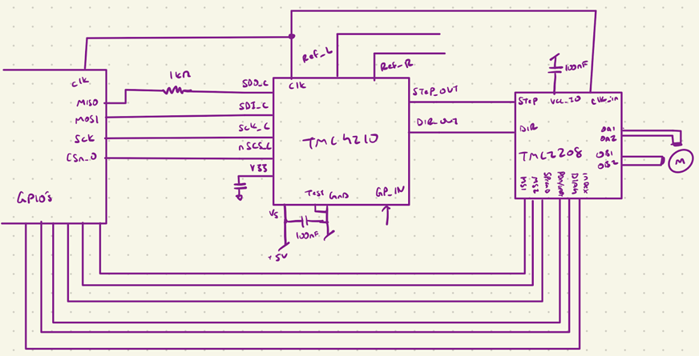

The next step was to write code to generate the correct clock signal at 20 MHz. The scope capture of it operating is shown below.

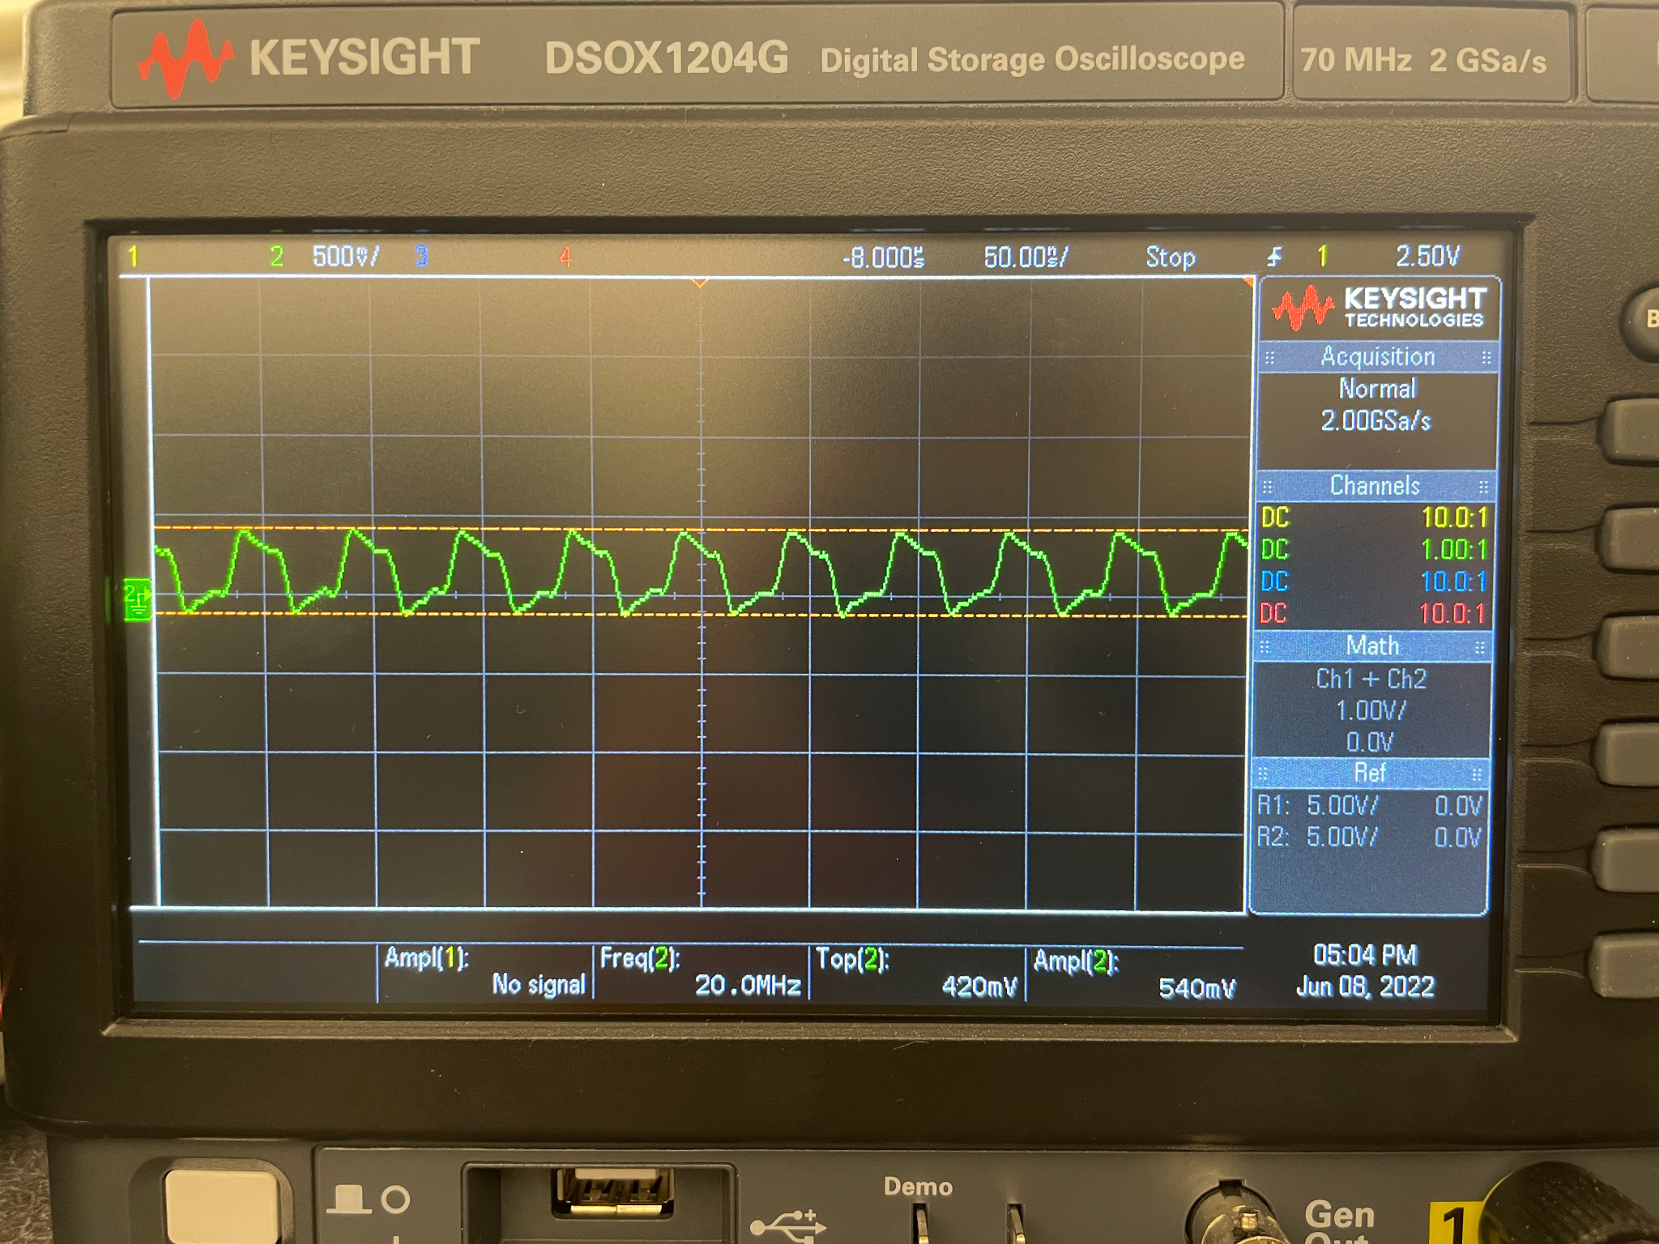

After the clock signal was verified, the next step was to verify that the data was being sent correctly. The scope captures below show both MOSI and MISO lines. Note that the yellow signal is nCS1, green is SCK, and blue is CLK. The data is shown at the bottom using the serial decoding feature.

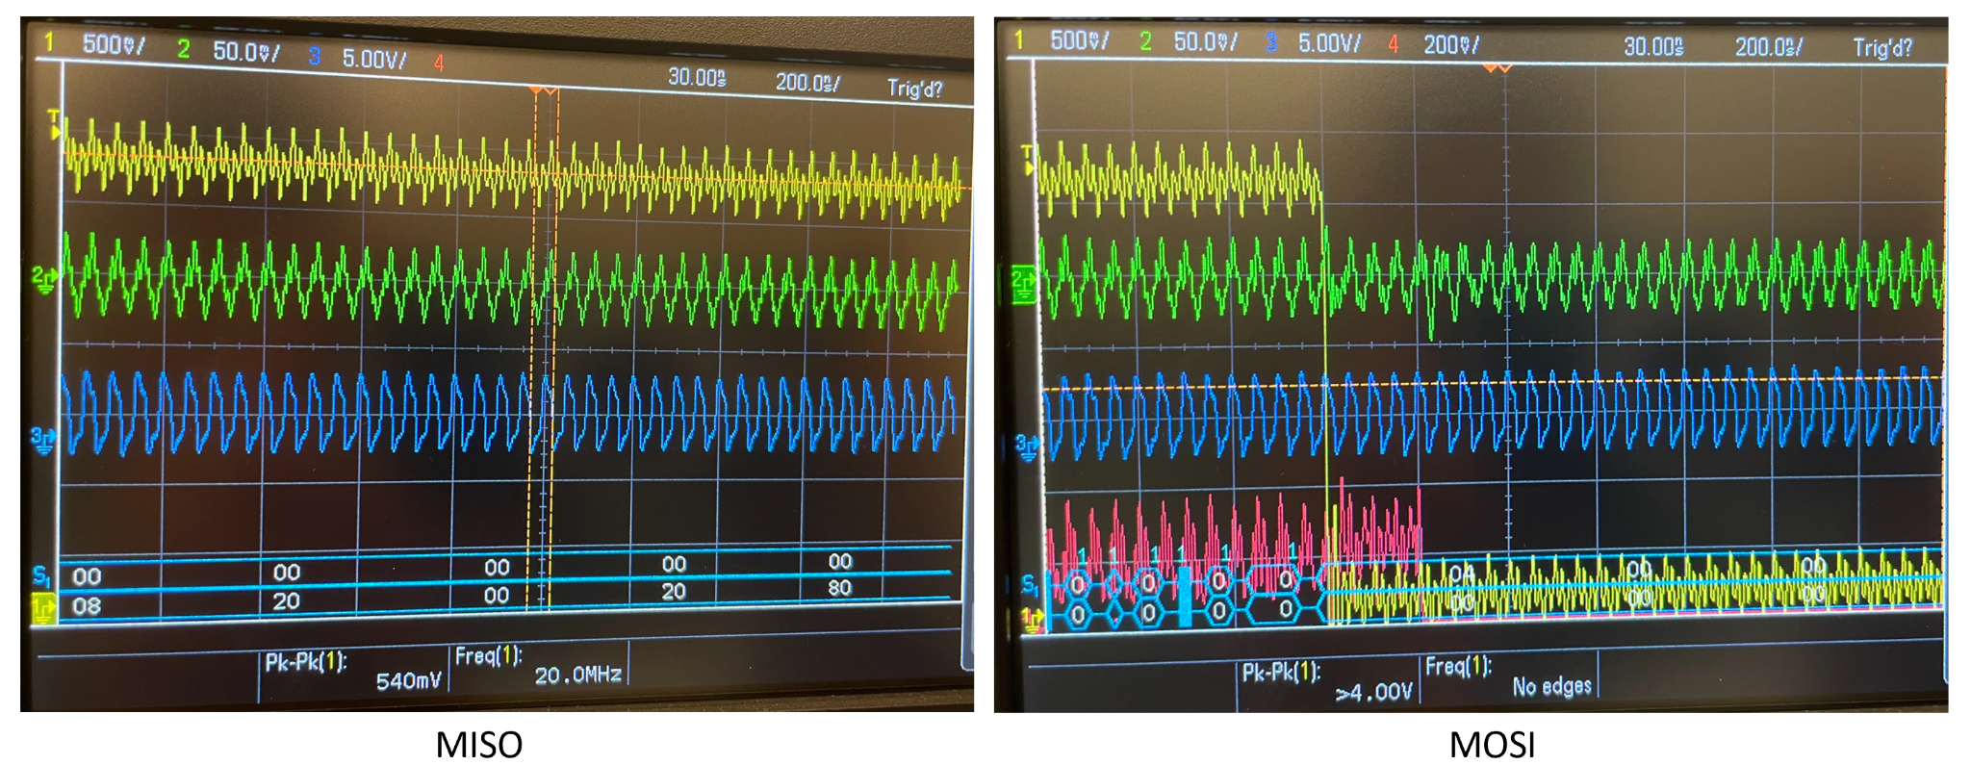

The data is also verified by printing it to the console. This is also shown in the image below.

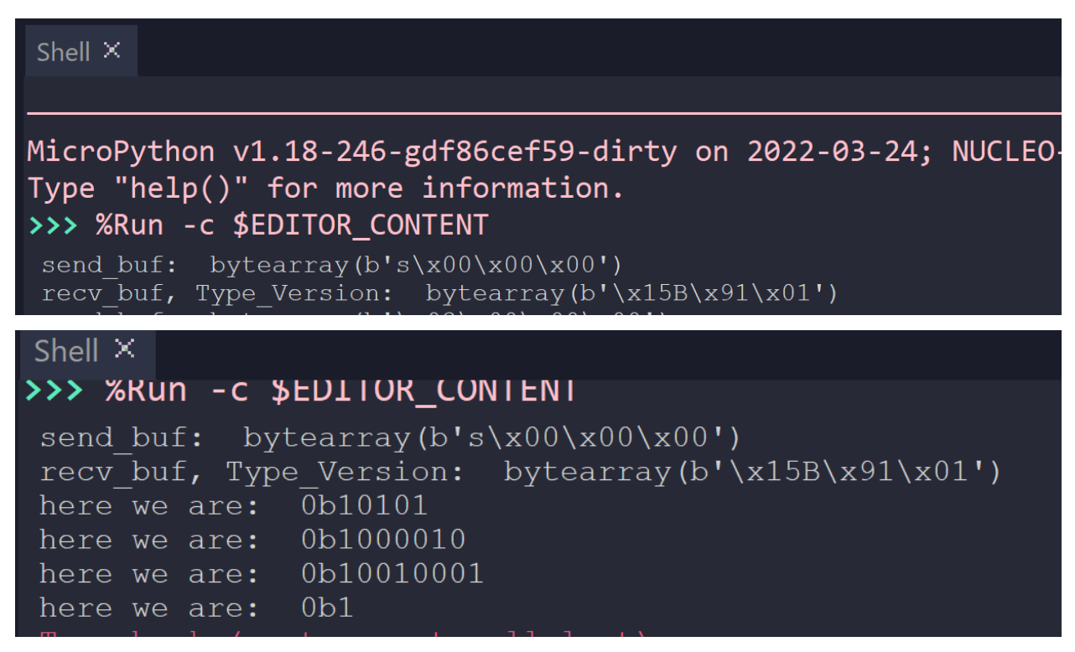

Lastly, a motor driver class was written to make the code more modular and object-oriented so that it can be made to integrate easily with other projects. A diagram of the class is shown.

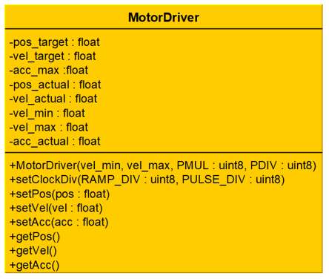

Finally, the motors can be seen in operation in the linked video: <https://drive.google.com/file/d/1Qb-K9VdT-8qYitZVEhLl1PaHGWKx7_Ab/view?usp=sharing>